Q67.

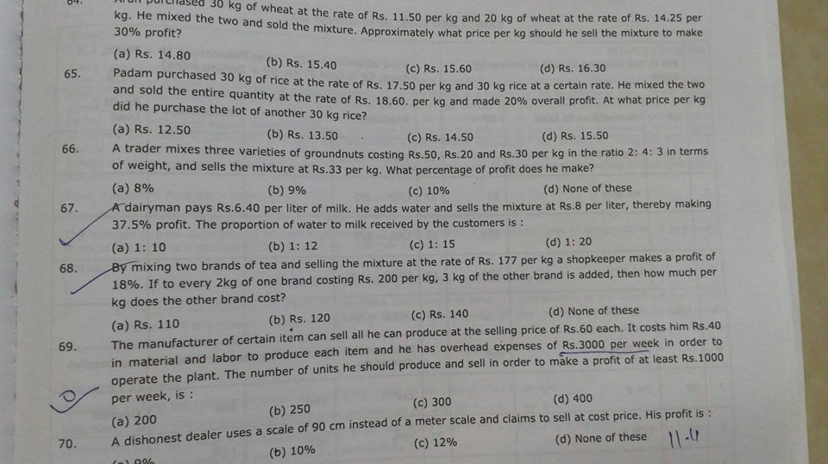

1 : 10. Let W/M = k. Mixture = M + Mk. SP of mix = 8(M+Mk) , CP of mix = 6.40M. Profit = [8(M+Mk) - 6.40M] / 6.40M = 0.375 . k = 1/10.

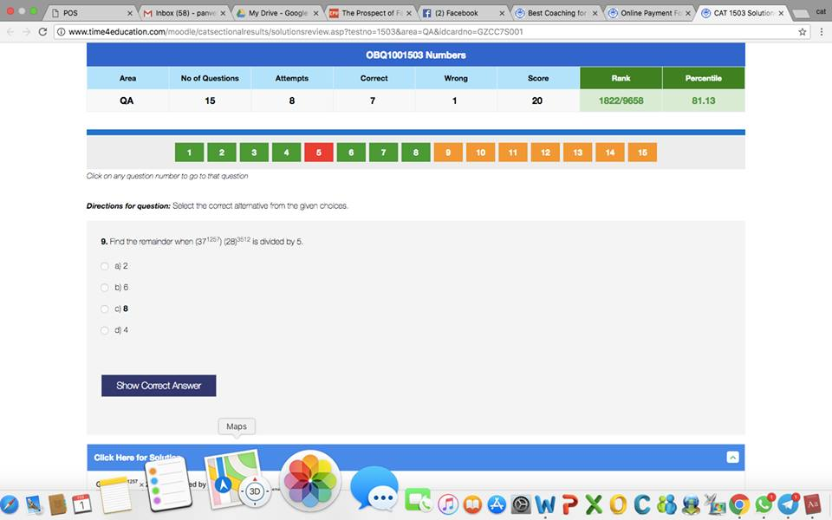

37^1257 mod 5 \* 28^3512 mod 5 = (37 \* 1) mod 5 = 37 mod 5 = 2.